AGDS – chapter 4 – report exercise

A time scheme of the Solar Radiation between May and September

Hypothesis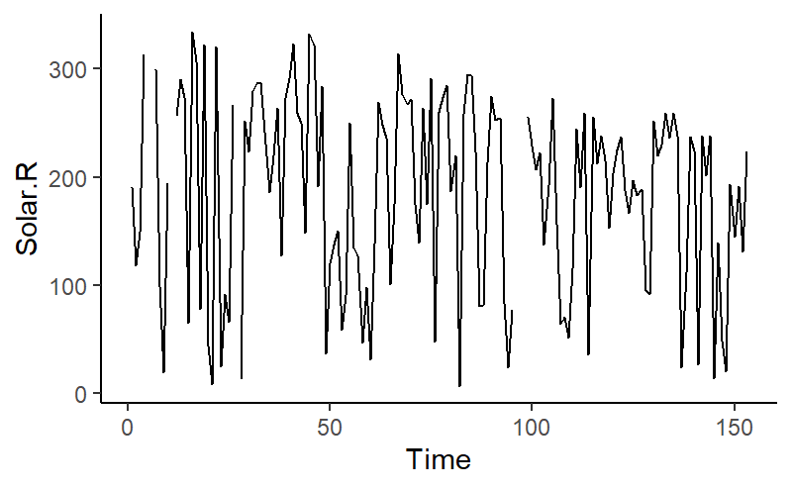

Hypothesis: There is a peak around the summer months June and July. (under the assumptions, that the measures where made in the northern hemisphere)

These are the fluctuations of the solar Radiation between May and September. I could have expected that there are visible patterns of fluctuations of the solar radiation over the seasons. I thought there will be a peak around June or July and sinks in May and September. In this figure, at least for me, this trend is not visible. My guess is that the measured Solar Radiation depends a lot on the weather. If there are clouds, the measure will become small.

Solar Radiation density

Ein Bild, das Diagramm enthält.

Hypothesis: when solar radiation is high, there are few clouds.

This figure gives a reference how the Solar Radiation is distributed. It shows the frequency density of the solar Radiaton. Very high numbers (above 300) are rare. There is a slight peak around 250. For lower values (approximately 0 to 220) there is no clear trend recognizable. The peak is in the right part of the figure. I think this suggests that generally the weather was quite good. Or according to my hypothesis, there was generally few cloud cover.

Solar Radiation and Temperature inclusive Regression line

Ein Bild, das Diagramm enthält.

Hypothesis: the higher the solar Radiation, the warmer it gets.

This is a simple scatterplot where the two variables solar radiation and temperature are plotted against each other. In addition, the Regression line is shown too. Following statistical metrics were calculated:

Numbers for the regression line:

Intercept: 61.743

Slope: 4.847

t = 3.4437

df = 144

p-value = 0.0007518

95% conf int: 0.1187113 0.4194913

Cor cof: 0.2758403

The p-Value is lower than 0.05 and even smaller than 0.01. generally that means, that the numbers used to calculate the p-value suggest a statistical significant correlation between the two variables. Therefore the hypothesis is not falsified with this data.

Boxplot of the Wind data (for the completeness of the exercise)

Ein Bild, das Diagramm enthält.

The variable wind gave the most interesting boxplot. All the other variables did not have any outliers. The median is approximately 10 and the Interquartile range spreads from 7 to 12. All data is within the 1.5 times the IQR plus or minus the 0.75 or the 0.25 quantile, except 3 points. Two are around 20 and one is a little below. The unit is miles per hour.